Предмет: Английский язык
на тему: Books in our life
в группе (специальность): №106 «Вычислительная техника и программное обеспечение»
преподаватель: Хурметбек К.К.

Урок разработан по технологии модульного обучения М.М. Жанпеисовой, структуре П.С. Гранкина с использованием РСЗОУ, ИКТ и ЦОР (электронный учебник).

1 | Тема урока | Books in our life
2 | Цели урока  Aims of the lesson | Образовательная: Студенты будут иметь возможность работать с текстом и ответить на вопрос по правилам грамматики, использовать свои знания.  Educational: Students will be able to work with text and to answer the question according to grammar rules, to use their knowledge.  Развивающая: Развивать у обучающихся чтение, письмо, запоминание и разговорные навыки.  Developing: To develop students’ reading, writing, remembering and speaking skills.  Воспитательная: воспитывать любовь и уважение к родному языку и иностранному языку  Bringing up: to bring up love and respect to the homeland, to the native language and foreign language;
3 | Тип урока  Type of the lesson | Совершенствование знаний  Lesson of generalization and systematization of knowledge
4 | Форма урока  Form of the education: | Работа в группах, индивидуальная работа, работа в паре  Work in group, individual work, work in pairs;
5 | Метод обучения | Conversation, explanation
6 | Межпредметная связь | Kazakh language, Russian language
7 | Материально-техническое обеспечение | Work with different card, interactive board, grammatical table, e-book

Plan of the lesson/План урока
№ | Этапы внеурочного мероприятия  / Stage of the lesson | Время/ Time | Баллы/Marks
1 | Organization moment | 3 min
2 | Checking up the home task | 5mib | 5b
3 | Vocabulary  Activity 1 – Choose the corresponding word to the following definition  Activity 2 - Choose the definition to the following definition  Activity 3 – Make up a word | 20 min | 15b
4 | Grammar  Activity 1 – Give the degrees of comparison of the following adjectives  Activity 2 – Write the opposite superlative adjective | 10 min | 10b
5 | Break time | 5min
6 | Work with text  Activity 1 – Fill in prepositions  Activity 2 – Choose and write the correct word given below  Activity 3 – True or False  Activity 4 – Answer the questions | 30 min | 15b
7 | Homework. Marks | 2 min

№ | Этапы урока/Stages of the lesson | Деятельность преподавателя/Activity of teacher | Деятельность обучающегося/Activity of students | Баллы/Marks | Ожидаемый результат/Expected result
1 | Organization moment | Good morning, dear teachers and children. How are you? I hope well! Today we have unusual lesson. I think our work will be very interesting and useful. | -Good morning teacher! We are fine! |  | The students can answer the questions
2 | Checking up the home task | - What was your home task for today? | Students answer to the questions | 5b | The students can read, write, translate, answer the questions
3 | Vocabulary  Activity 1 – Choose the corresponding word to the following definition  Activity 2 - Choose the words to the following definition  Activity 3 – Make up a word | The teacher gives the new words: ancient, well-known, printing, development, human, literature, scientific, adventure, library, librarian, look-through, self-education, novel, publish, art, play.  Art, printing, human, literature, ancient, scientific, novel  A book that tells a long story,  A new event, discovery that change things  Known by many people  Describes someone who studies and reads for himself  To produce and provide a book, a magazine or a newspaper for sale  Ribanalri, suplihb, tnienanc, irateluert, loven, readtenvu | Students listen and repeat after teacher and write down in their copybook  Students find definition to the word  Students find words to the definition  Students make up the words | 15b | Students can expand vocabulary  Fluency, to develop students’ reading, writing abilities
4 | Grammar: Adjectives  Activity 1 – Give the degrees of comparison of the following adjectives  Activity 2 – Write the opposite superlative adjective | Имя прилагательное – это самостоятельная часть речи, обозначающая признак предмета и отвечающая на вопросы «какой?», «который?», «чей?».  Английские прилагательные, в отличие от русских, не изменяются ни по падежу, ни по роду, ни числу:  small boy – маленький мальчик  small girl – маленькая девочка  small children – маленькие дети  Строение английских прилагательных  По своему строению английские прилагательные делятся на простые, производные и сложные.  Tea is …(popular) than the coffee UK  It is … (cheap) book in the shop  Moscow is …(big) than Almaty  He is a .. (famous) writer in this country  The hottest  The biggest  The cheapest  The youngest  The easiest  The best  The shoertest | The students repeat the new words and write down in copybooks  Students make the exxersice | 10b | The students can read, write, translate, answer the questions  Fluency, to develop students’ reading, writing abilities
5 | Break time | The teacher includes the music for gymnastic charging | The students stand up and do gymnastic
6 | Work with text  Activity 1 – Fill in prepositions  Activity 2 – Choose and write the correct word given below  Activity 3 – True or False  Activity 4 – Answer the questions | 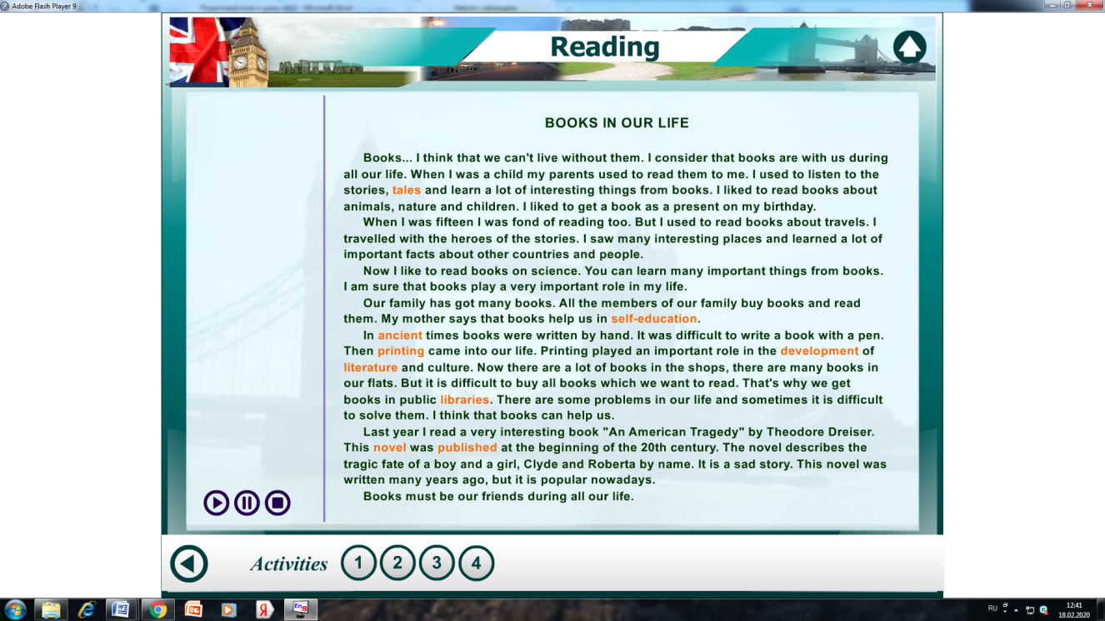  We can’t live… books  I liked to get a book as a present …my birthday  Shakespeare wrote Hamlet … 1603  There is nothing more wonderful than a,,,!  The book is certainly one of the greatest … of man.  It is a friend and a …#  Books teach… to live.  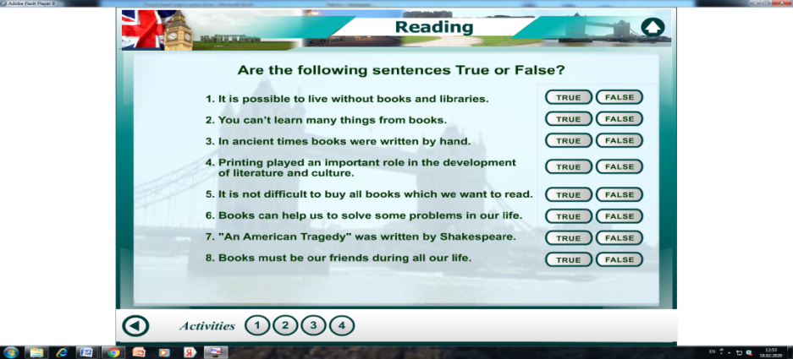  Are you fond of reading?  What role do books play in your life?  Do you have enough time for reading?  What kind of books do you read?  Who is your favourite writer? | Students work with the text. They will read and translate the text and take notes  Students find right prepositions and fill it.  Students find right words and write it.  Students answer the questions  Students answer the questions | 15b | The students can read, write, translate, answer the questions  Fluency, to develop students’ reading, writing abilities
6 | Homework. Marks | Teacher gives home task: To learn the key words and do 5 sentences using new words .  Put them marks of the lesson  Примерные критерий оценок  A rough criterion for estimates  39 - 45 b – 5  29 - 38 b – 4  19 – 28 b - 3 | The students write in home task on their copybook |  | Fluency, to develop students’ reading, writing abilities

